17.76: The power input will be equal to 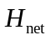 as given in Eq. (17.26);

